Car or Cup?

车子还是杯子

In this project you will make a Scratch project that learns to sort photos.

在这个项目中你将通过scratch制作分类图片的项目

Your class will work together to train the computer to be able to sort a set of photos into two piles:

one pile of photos of cars, and

one pile of photos of cups

你的班级将共同合作，训练计算机学习分类两种图片，一是车子、二是杯子

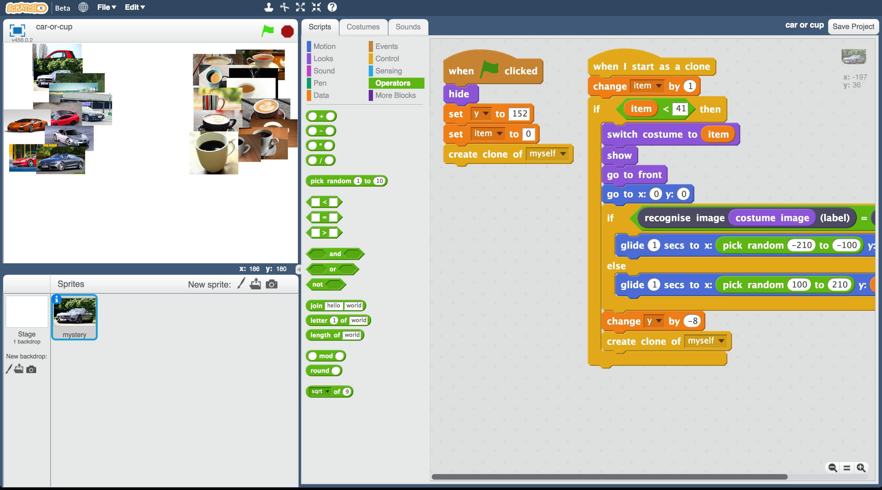

This project worksheet is licensed under a Creative Commons Attribution Non-Commercial Share-Alike License <http://creativecommons.org/licenses/by-nc-sa/4.0/>



**Teacher / Group leader instructions : Setup**

**老师/组长说明书：步骤**

This version of the “Car or Cup” activity will get your class to work together to train a single machine learning model. A version of this activity where students can work individually to each train their own machine learning can be downloaded from https://machinelearningforkids.co.uk/worksheets

这个版本的“汽车或杯子”活动将让您的班级一起训练一个的机器学习模型。在这个活动中，学生可以独立工作，训练他们自己的机器学习模型。且可以从https://machinelningforkids.co.uk/worksheets下载教程。

**Objective:** Create a group project & prepare it for use by your class

**目标:创建一个小组项目，并为你的班级准备**

1. Go to https://machinelearningforkids.co.uk/ in a web browser

访问<https://machinelearningforkids.co.uk/>网站

1. Login using your teacher username/password

登陆您的教师用户

1. Click on “Projects” in the top menu bar

点击上方菜单栏“Projects”(项目)按钮

1. Click on the “+ Add a new project” button

点击“+Add a new project”(新增项目)按钮

1. Create a project called “Car or Cup”, set to recognise “images” and make sure you tick the “Whole-class project” checkbox

创建一个名为“车子还是杯子”的项目，设置为识别“image”，并确保选中“whole class project”复选框

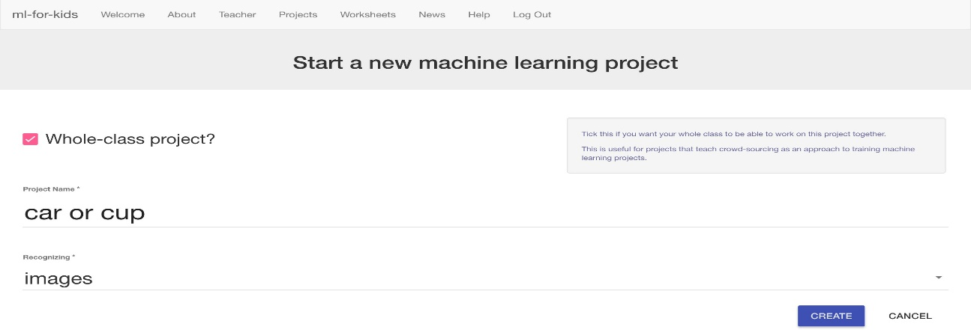

1. Click “Create”

点击“Create”(创建)按钮

1. Click on the “Car or Cup” project in the list, and then click “Train”

点击“车子还是杯子”项目后点击“Train”(训练)按钮

1. Use the “+ Add new label” button to create training buckets for Car and Cup

点击“+ Add new label”按钮为车子、杯子图片创建训练分栏

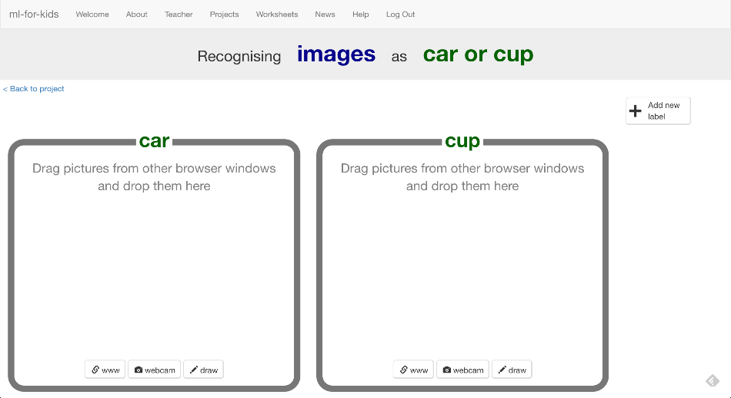

**Student instructions**

**学生说明书**

1. Go to https://machinelearningforkids.co.uk/ in a web browser

访问<https://machinelearningforkids.co.uk/>网站

1. Click on “Get started”

点击“Get started”(开始吧)按钮

1. Click on “Log In” and type in your username and password

点击“Log In”(登陆)按钮，输入你的用户名、密码

If you don’t have a username, ask your teacher or group leader to create

one for you.

如果你没有一个用户名,请求你的老师或组长为你创建一个

If you can’t remember your username or password, ask your teacher or group leader to reset it for you.

如果你不记得你的用户名或密码，请你的老师或组长帮你重新设置。

1. Click on “Projects” on the top menu bar

点击上方菜单栏“Projects”(项目)按钮

1. You should see a “car or cup” project created by your teacher. Click on it.

你应该会看到由老师创建的名为“car or cup”(车子还是杯子)项目，点击它

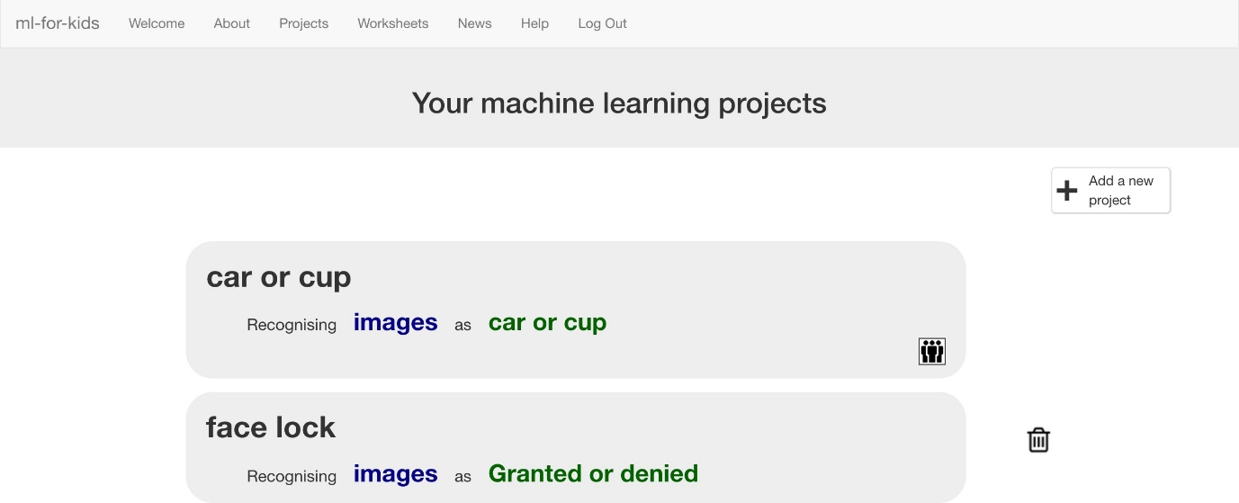

1. Click the “Train” button to start collecting examples of photos to train the computer with.

点击“Train”(训练)按钮以开始收集图片作为计算机的训练数据

1. Your teacher has prepared training buckets for pictures.

你的老师为不同类的图片准备了分栏

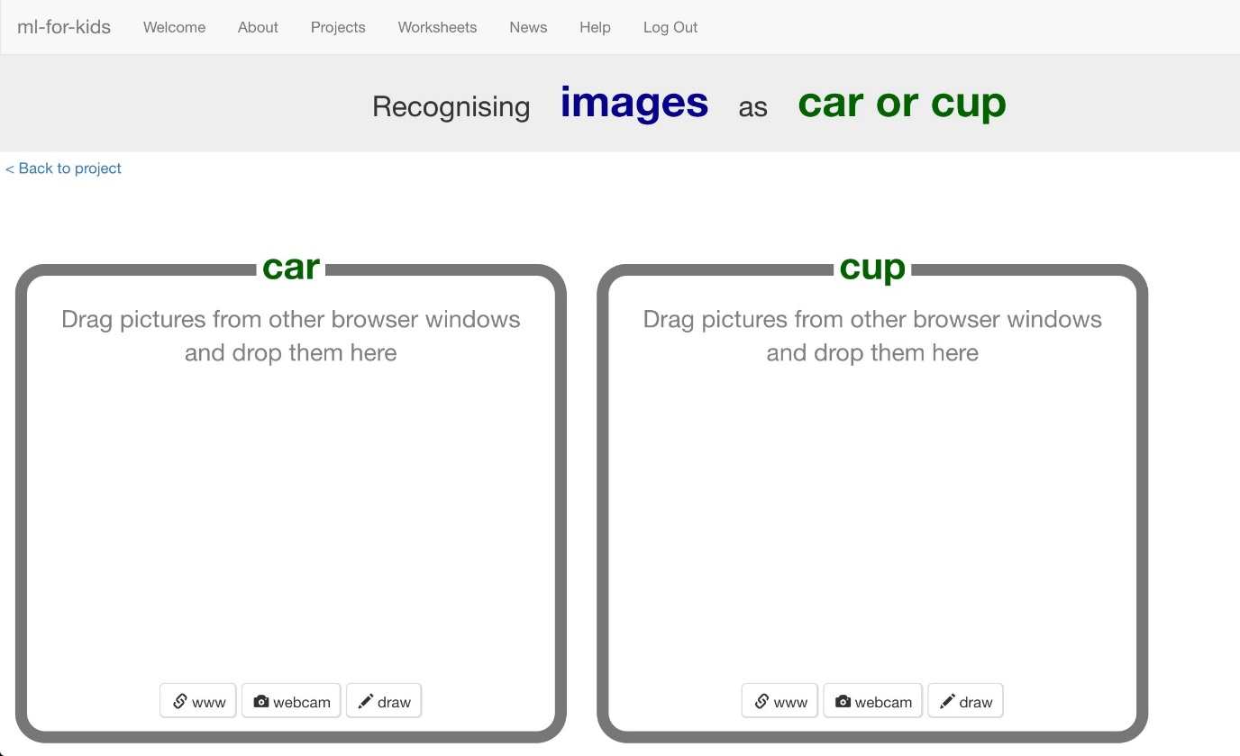

1. Open another web browser window.

新建一个浏览器窗口

1. Arrange the web browser windows so that they are side by side.

并排这两个浏览器。

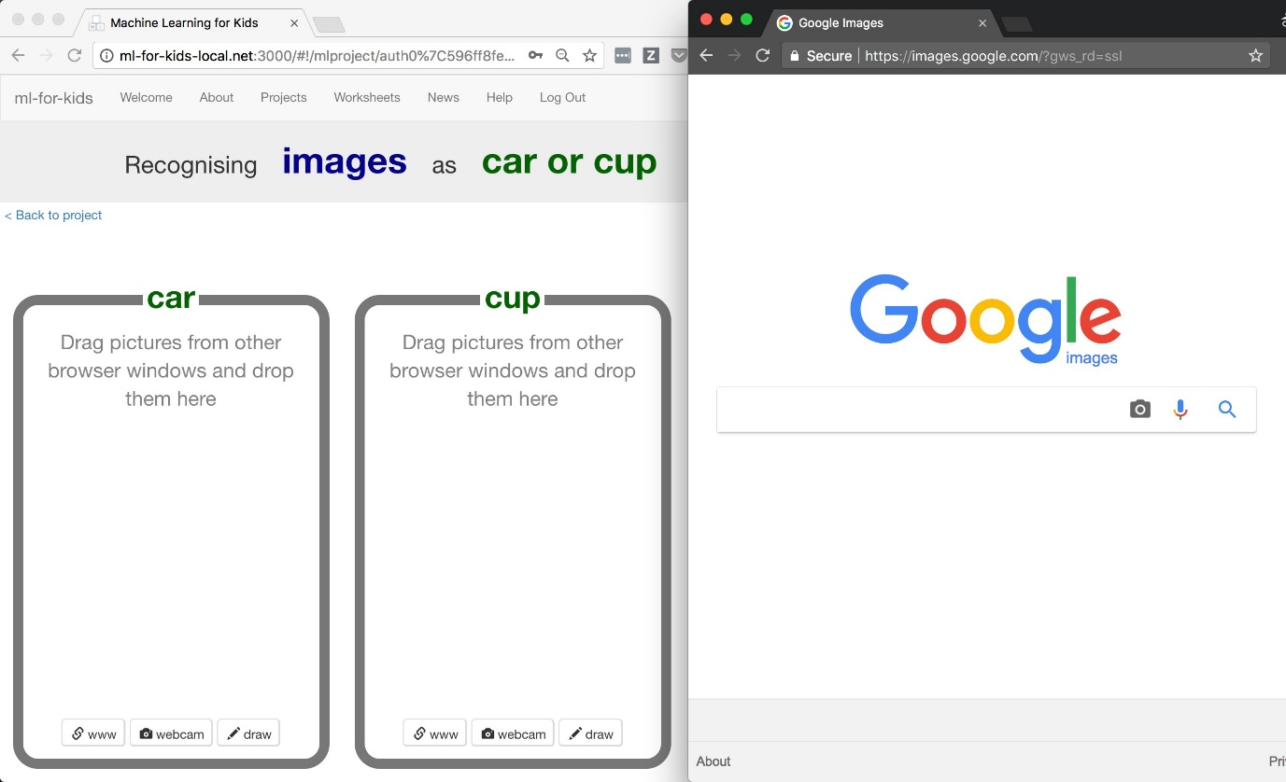

1. In the new browser window, search for pictures of cars. Drag pictures that are good examples of a car into the left bucket.

在新开的窗口中搜索关于汽车的图片，并将其拖入原窗口对应的分栏中

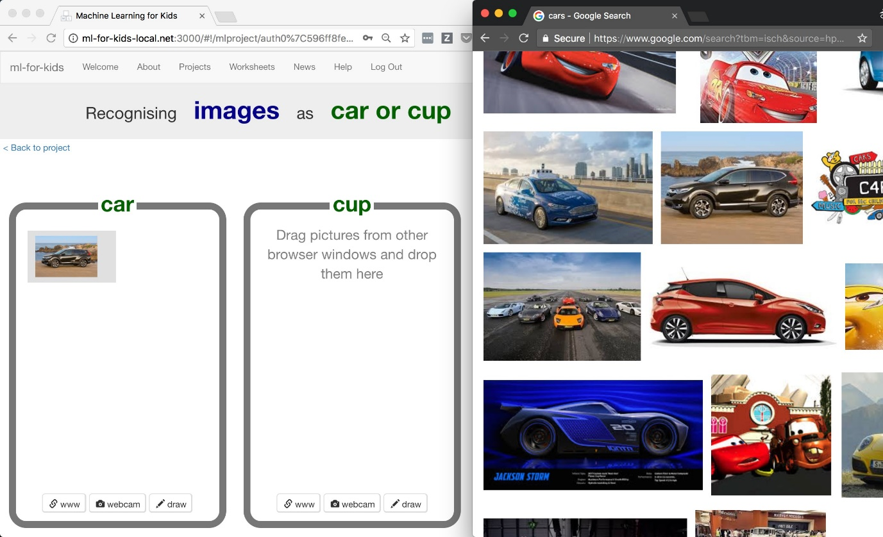

1. Repeat until you’ve collected a few examples of car photos.

一直重复直到收集到足够多的照片

1. Search for pictures of cups.Drag pictures that are good examples of a cup into the right bucket.

在新开的窗口中搜索关于杯子的图片，并将其拖入原窗口对应的分栏中

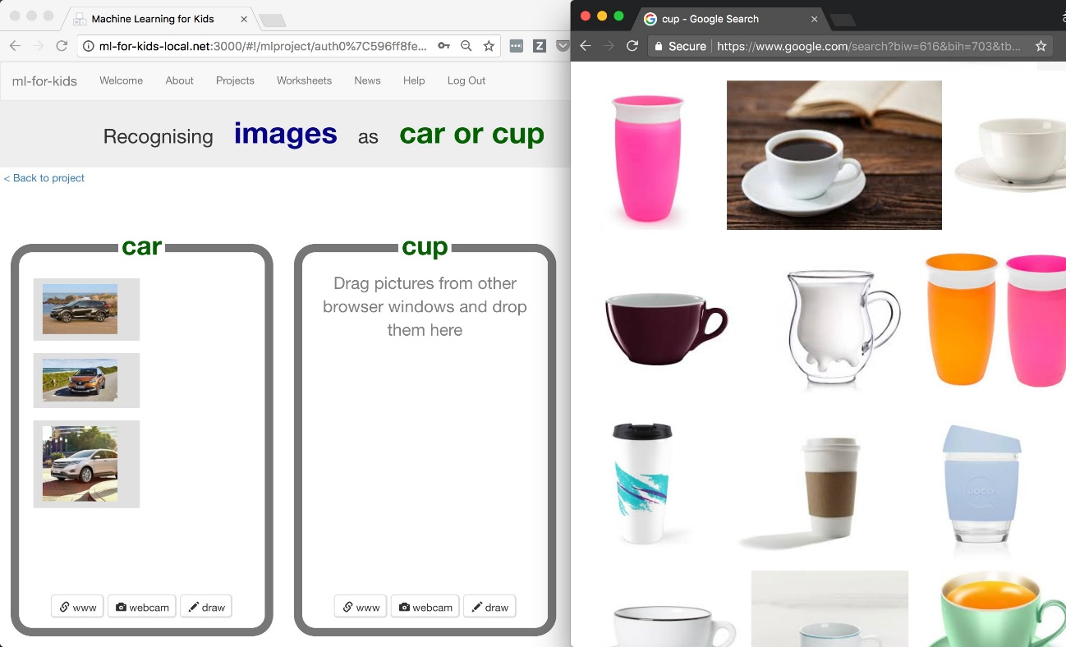

1. Repeat until you have collected a few examples of cup photos.

一直重复直到收集到足够多的照片

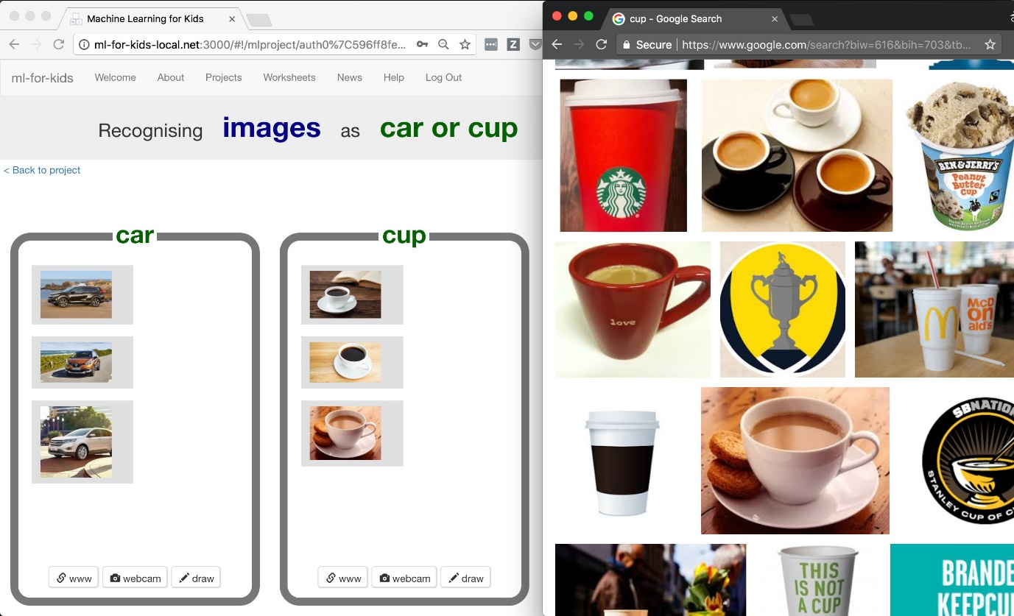

1. Your classmates will also be adding photos to the same training buckets as you, but they won’t show up while you’ve got the page open. Refresh the page to see all the training so far from the whole class.

你的同学也会把图片添加到你的训练分栏中，但是当你打开页面时，并不会显示。

请刷新页面，查看整个类别的所有训练数据

1. Keep going until your class have collected enough examples.

持续操作直至该类收集到足够多的训练样本

1. Don’t move past this step until your teacher tells you it’s time to move on.

不要跳过这一步骤直到你的老师告诉你继续

**Teacher / Group leader instructions : Train a ML model**

**老师/小组组长说明书：训练一个机器学习模型**

**Objective:** Monitor class progress & train a machine learning model

**目标：监管训练过程 & 训练一个机器学习的模型**

1. Click on “Projects” in the top menu bar

点击顶部菜单栏“Projects”(项目)按钮

1. Click on the “car or cup” project

点击“car or cup”(车子还是杯子)项目

1. Click on the “Learn & Test” button

点击“Learn & Test”(学习&测试)按钮

1. Review the summary of the progress the class has made

复习该类进度总结

*The more examples they collect, the better the model should perform, but they need*

*at least ten examples of each to be able to create a model at all.*

*当你收集的样本数据越多，那么模型表现应该越好。但是至少需要十个样本以创建模型*

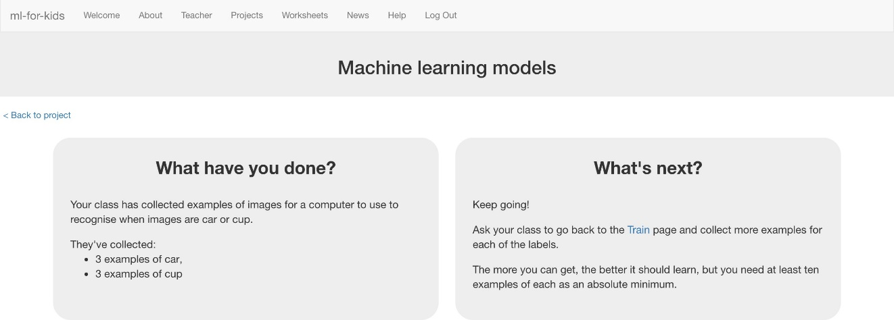

1. When you’re ready to proceed, click “Train new machine learning model” to train a new model using their examples.

当你准备好时，点击“Train new machine learning model”(训练新的机器学习模型)使用这些数据训练一个新的模型

1. This may take a minute or two. The status on the page will change from “Training” to “Active” once it has finished.

这将会持续1~2分钟。一旦该页的状态从“Training”(训练中)变成“Active”(活跃)就完成训练

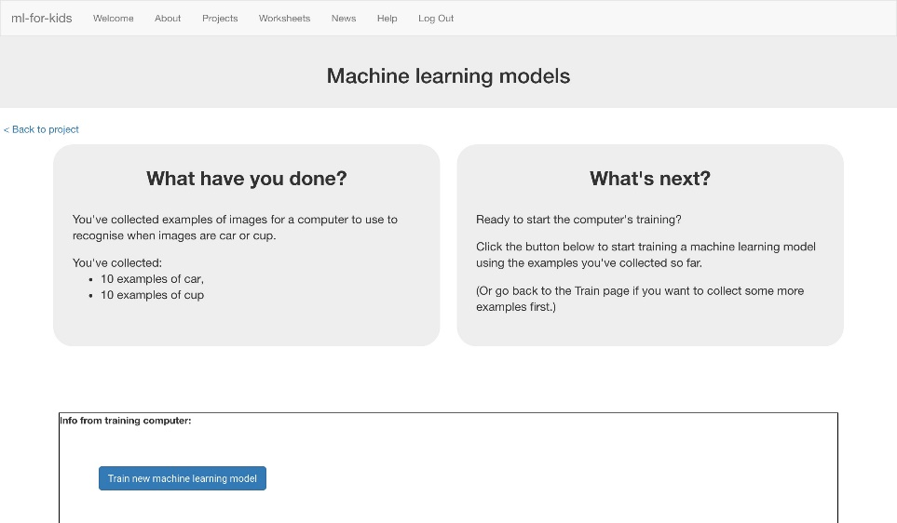

1. Once it is ready, you can tell the class it’s time to move on.

一旦准备好了，你可以告诉班级同学可以继续

**Student instructions**

**学生说明书**

1. Click the “< Back to project” link.

点击“< Back to project”(回退至项目)

1. Your teacher has used the examples your class collected to train a machine learning model.

你的老师会使用班级收集的数据来训练一个机器学习模型

1. Click the “< Back to project” link, then the “Scratch” button.

点击“< Back to project”(回退至项目)，然后点击“Scratch”按钮

1. This page has instructions on how to use the new blocks in Scratch. Keep the page open if you need to check back on how to use them

这个页面将知道你如何在Scratch中如何使用新的区域

如果你需要再次确认如何使用那就请保持这个页面常开.

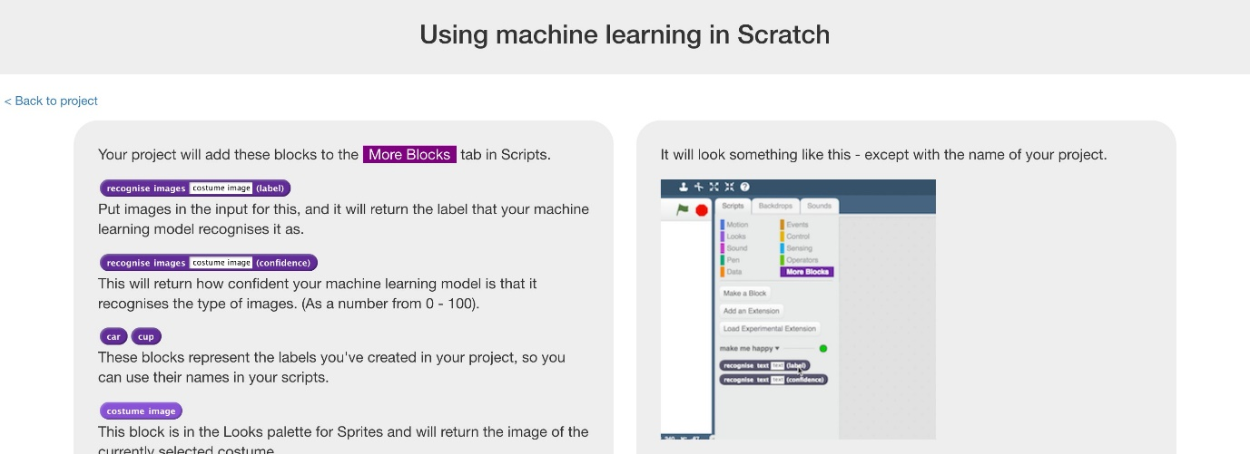

**What have you done so far?**

你做了些什么？

You’ve started to train a computer to recognise pictures of cups and cars. Instead of trying to write rules to be able to do this, you are doing it by collecting examples. These examples are being used to train a machine learning “model”.

你已经开始训练计算机来识别杯子和汽车的图片。与其试图编写规则来实现这一点，

不如通过收集样本图片来实现这一点。这些例子被用来训练机器学习的“模型”

This is called “supervised learning” because of the way you are supervising the computer’s training.

这被称为“监督学习”，因为你监督计算机训练的方式

The computer will learn from patterns in the example photos you’ve chosen, such as the shapes and the use of colour. These will be used to be able to recognise new images.

计算机将从您所选择的样本照片中学习，例如形状和颜色的使用。它们将被用来识别新的图像。

1. Click the “Open in Scratch” button to launch the Scratch editor. You should see three new blocks in the “More blocks” section from your “car or cup” project.

单击“Open in Scratch”按钮以启动Scratch编辑器。

您应该在““car or cup”项目的“More blocks”部分看到三个新的区域

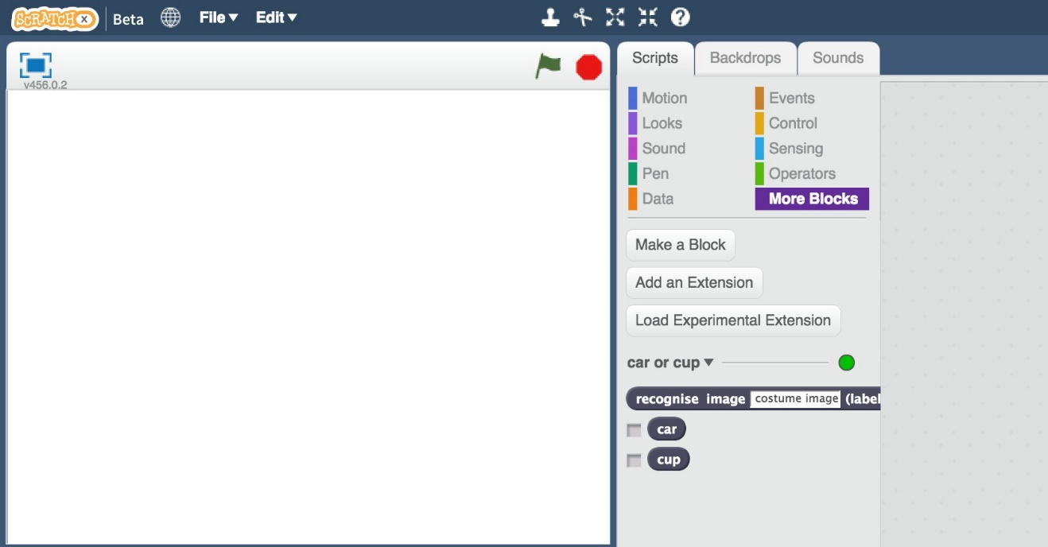

1. Load the Car or cup template

Use Project templates -> Car or cup as shown below.

加载Car or cup的模板

如下图所示，点击Project templates的 Car or cup

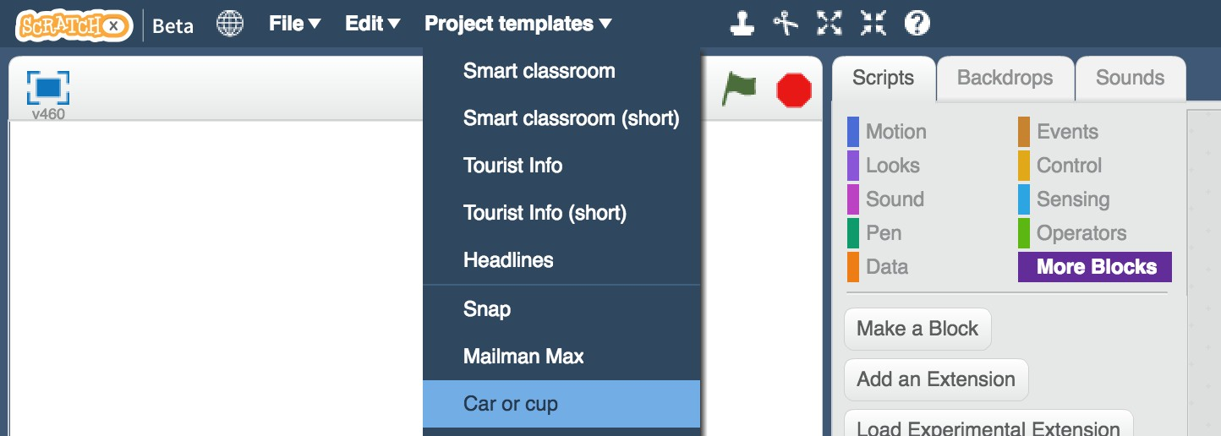

**More examples!**

**更多训练样本！**

The more examples you give it, the better the computer should get at recognising whether a photo of your hand is rock, paper or scissors.

当你提供越多关于“石头、剪刀、布”的照片、能够使计算机更好地学习识别他们

**Try and be even**

**尝试公平**

Try and come up with roughly the same number of examples for each shape.

**试着为每个形状提供大致相同数量的样本。**

If you have a lot of examples for one type, and not the other, the computer might learn that type is more likely, so you’ll affect the way that it learns to recognise photos.

如果你有很多关于一种类型的例子，而另一种类型的很少时，计算机训练时可能会认为更有可能是前种类型的图片，所以你会影响计算机学习图像识别的过程

**Mix things up with your examples**

**得到多种不同方式的同类样本**

Try to come up with lots of different types of examples.

**尝试得到不同类型的样本图片**

For example, you could include examples of your hand coming from the left side of the photo as well as examples of your hand coming from the right side.

举个例子，你可以用左右手来拍照同一类的照片

**Tips** 小技巧

1. Click the green flag to give it a try.

The project has forty random photos or cars or cups.

Next you will modify the project to use the training you’ve given the computer, so that it can sort these photos into two piles.

点击绿色的标志来尝试一下。

该项目已经拥有四十张汽车或杯子的随机照片。

接下来,您将修改该项目来训练你的电脑,以将这些照片分成两类

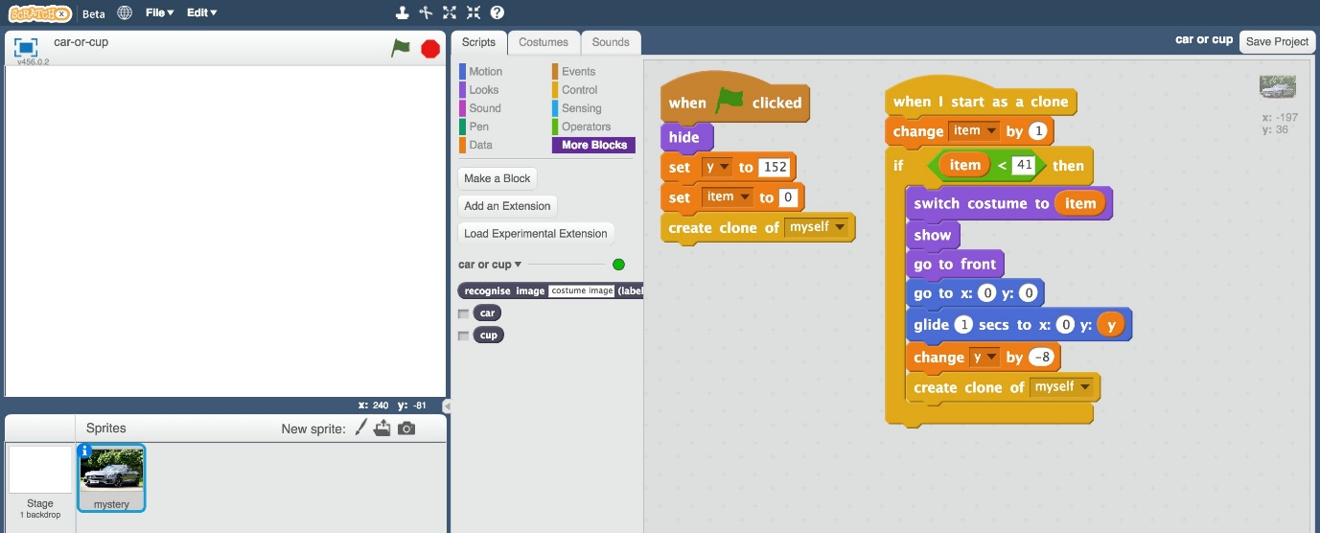

1. Click on the “mystery” sprite, and then click “Scripts” tab, and change the script to use your machine learning model.

单击“神秘”的角色，然后单击“Scripts”选项卡，并更改脚本以使用您的机器学习模型

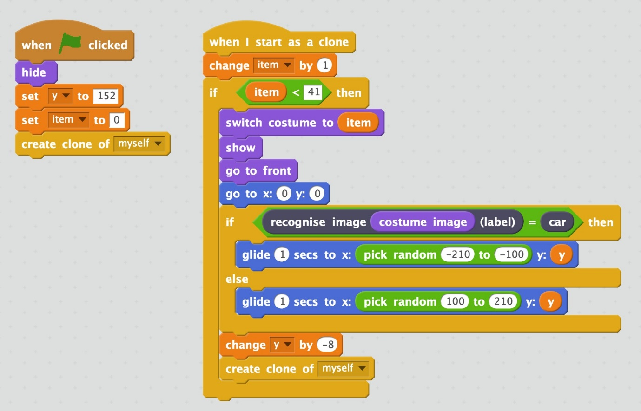

1. Click the full screen icon, and then click the green flag

点击全屏图标然后点击绿色旗帜标识

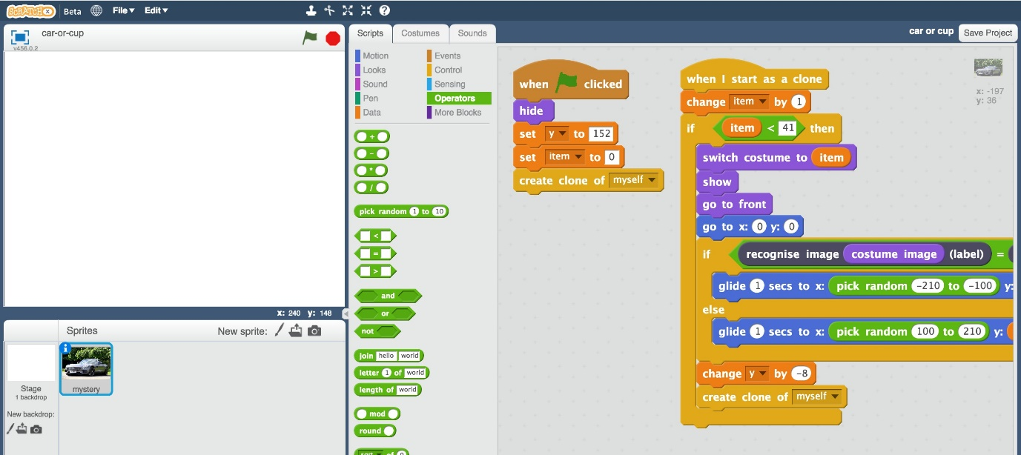

1. Watch your script use the machine learning model you’ve trained to sort the photos into two piles.

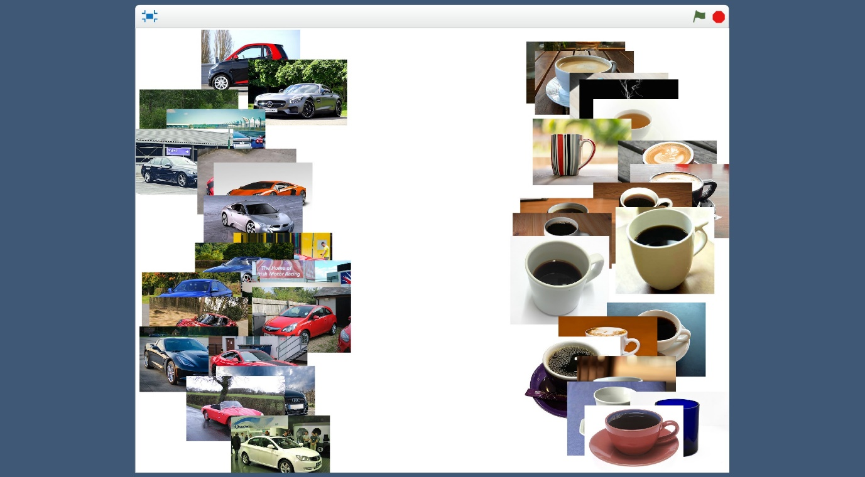

观察使用你训练过的把照片分成两类的机器学习模型的脚本

1. If your trained system makes mistakes, you’ll need to go back to step 14, and collect more examples.

Make sure you repeat step 18 to train a new model with the extra examples that you’ve collected.

如果您训练过的系统出错，您需要回到步骤14，并收集更多示例图片，并确保你重复步骤18训练新模型

1. Save your project.

Click File -> Save project

保存项目

点击File 再点击Save project

**What have you done?**

**你做了些什么？**

You’ve used machine learning to build an automatic photo sorter.

***你使用机器学习搭建了一个自动图片分类器***

Training the computer to be able to recognise photos for itself is much much quicker than trying to sort thousands of photos manually.

***训练计算机能够自己识别照片，要比手工分类成千上万张照片快得多***And the more examples you give it, the better it should get at recognising photos correctly.

你给的训练图片越多，它就越能正确识别照片。

|  |
| --- |
|  |
| **Ideas and Extensions**  **扩展延伸** |
| Now that you’ve finished, why not give one of these ideas a try? Or come up with one of your own?  既然你已经完成了，为什么不尝试一下这些想法呢?  或者想出一个你自己的分类器?  **Add a third type of photo**  **新增第三类图片**  Instead of just recognising cups and cars, can you add a third type as well?  你能添加第三种类别而不只是识别杯子和汽车?  **Try confusing the computer**  Train the computer to recognise cars with ten photos of a car on a grass background.  Train the computer to recognise cups with ten photos of a cup on a plain white background.  *通过10张在草地上的汽车的照片来训练。*  *通过10张在白色背景的杯子的照片来训练*  Now see if the computer recognises a car on a plain white background.  现在看看电脑是否能识别出纯白色背景的汽车。  Or if it can recognise a cup on a grass background.  或者如果它能在草地的背景上认出杯子。  Does the computer get confused? Did it learn to recognise the cup and car? Or was it more influenced by the background?  电脑感到困惑吗?它学会识别杯子和汽车了吗?还是更受背景的影响?  Experiment to find out how the computer learns, and how it behaves.  通过实验了解计算机是如何学习的，以及它是如何工作的。 |